ANITHA.A ASSIGNMENT 03

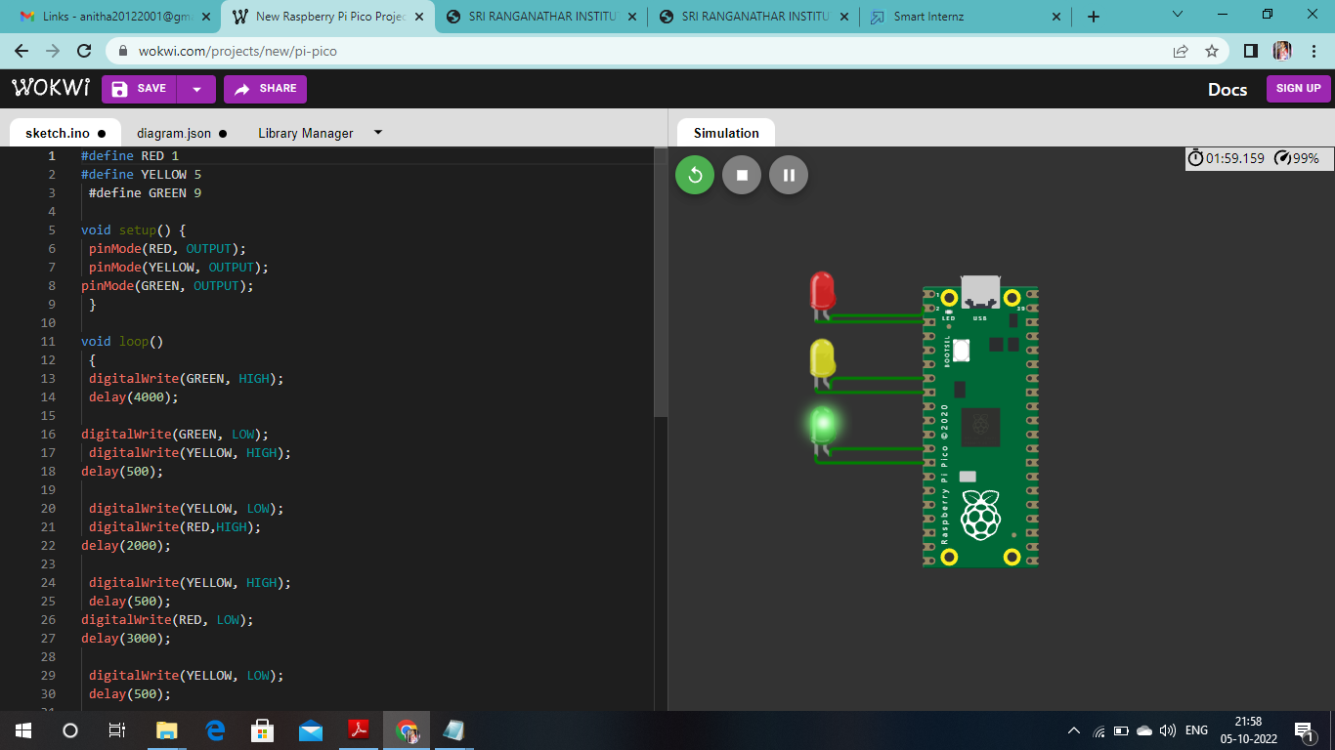

CODE

#define RED 1

#define YELLOW 5

#define GREEN 9

void setup() {

pinMode(RED, OUTPUT);

pinMode(YELLOW, OUTPUT);

pinMode(GREEN, OUTPUT);

}

void loop() {

digitalWrite(GREEN, HIGH);

delay(4000);

digitalWrite(GREEN, LOW);

digitalWrite(YELLOW, HIGH);

delay(500);

digitalWrite(YELLOW, LOW);

digitalWrite(RED,HIGH);

delay(2000);

digitalWrite(YELLOW, HIGH);

delay(500);

digitalWrite(RED, LOW);

delay(3000);

digitalWrite(YELLOW, LOW);

delay(500);

digitalWrite(GREEN, HIGH);

delay(3000);

**PYTHON CODE FOR TRAFFIC LIGHT**

**CODE:**

x = input("Enter value: ")

traffic_light = int(x)

while True:

if traffic_light >= 1 and traffic_light < 10:

print('Green light')

traffic_light += 1

elif traffic_light < 20:

print('Yellow light')

traffic_light += 1

elif traffic_light < 30:

print("Red light")

traffic_light += 1

else:

traffic_light = 0

break

**OUTPUT:**

Enter value: 28

Red light

>>>

==================== RESTART: D:/Anitha.py/TRAFFIC LIGHT.py ====================

Enter value: 2

Green light

>>>

==================== RESTART: D:/Anitha.py/TRAFFIC LIGHT.py ====================

Enter value: 11

Yellow light

>>>

BLINKING LED

x=input("ENTER VALUE:")

BLINK_LED=int(x)

while True:

if BLINK_LED>=100:

print("LED IS BLINKING")

else:

print("NIL")

BLINKING LED

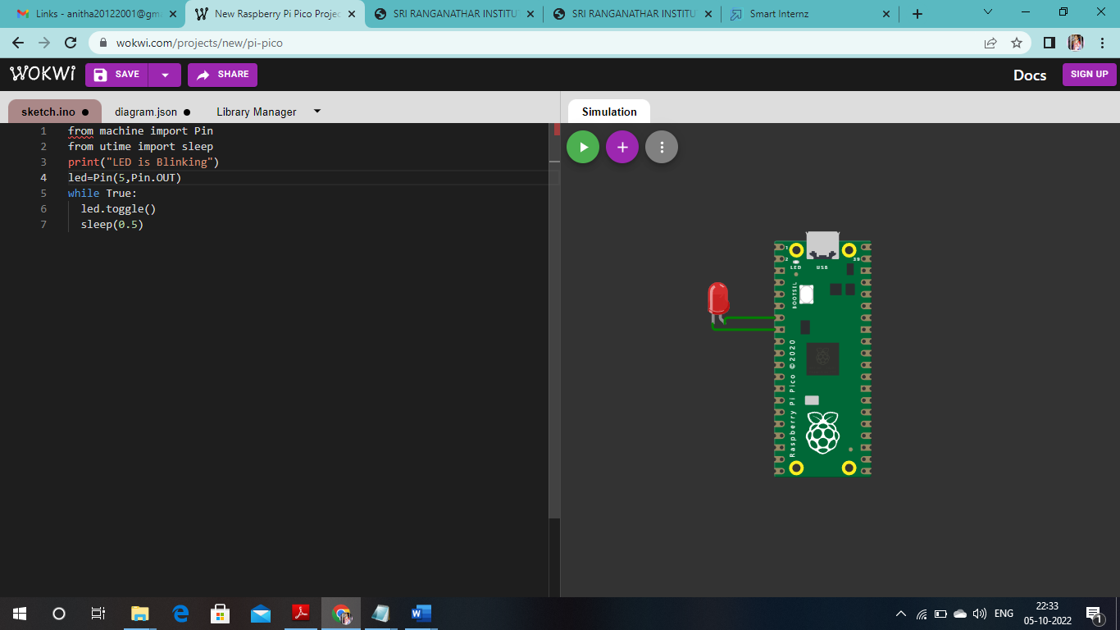

CODE

from machine import Pin

from utime import sleep

print("LED is Blinking")

led=Pin(5,Pin.OUT)

while True:

led.toggle()

sleep(0.5)

**PYTHON CODE FOR BLINKING OF LED:**

**CODE:**

x=input("ENTER VALUE:")

BLINK_LED=int(x)

while True:

if BLINK_LED>=100:

print("LED IS BLINKING")

else:

print("NIL")

**OUTPUT:**

Enter value:1207

LED IS BLINKING

LED IS BLINKING